**Assisted Practice: 3.11 Create a Bucket**

**Step 3.11.1:** Selecting S3 from the storage of the AWS service panel

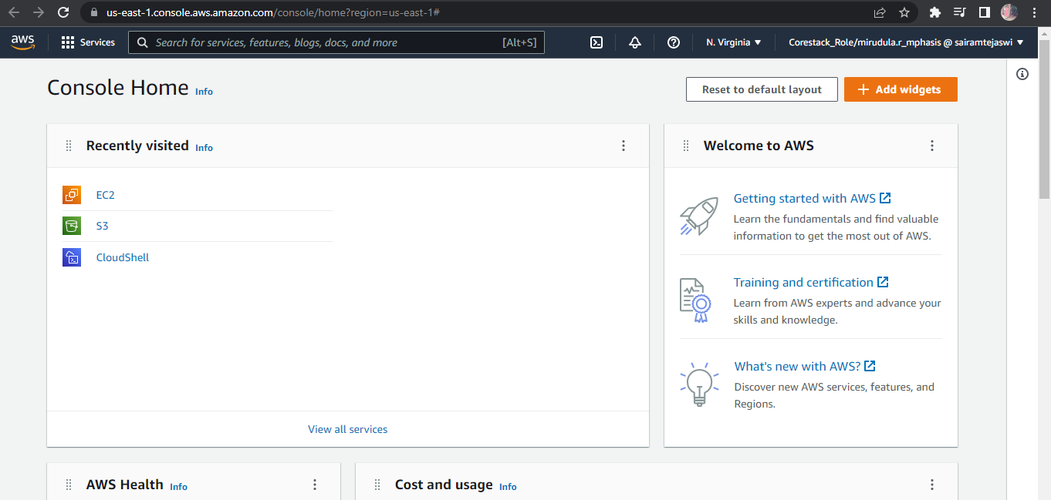

**Step 3.11..2:** Verifying the button to create a bucket

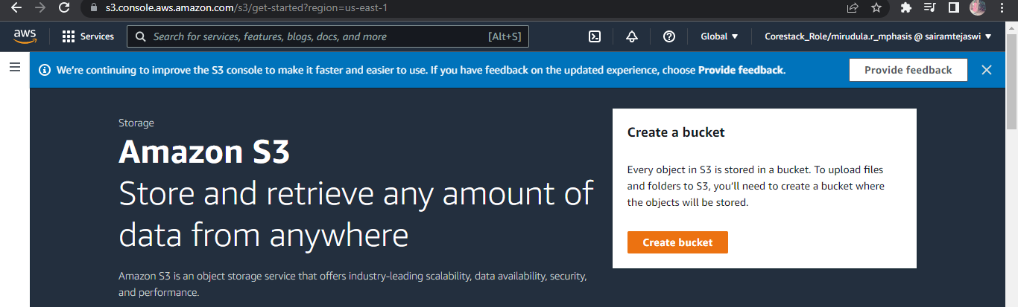

**Step 3.11.3:** Providing a bucket name and region

* Make sure that the bucket name is unique

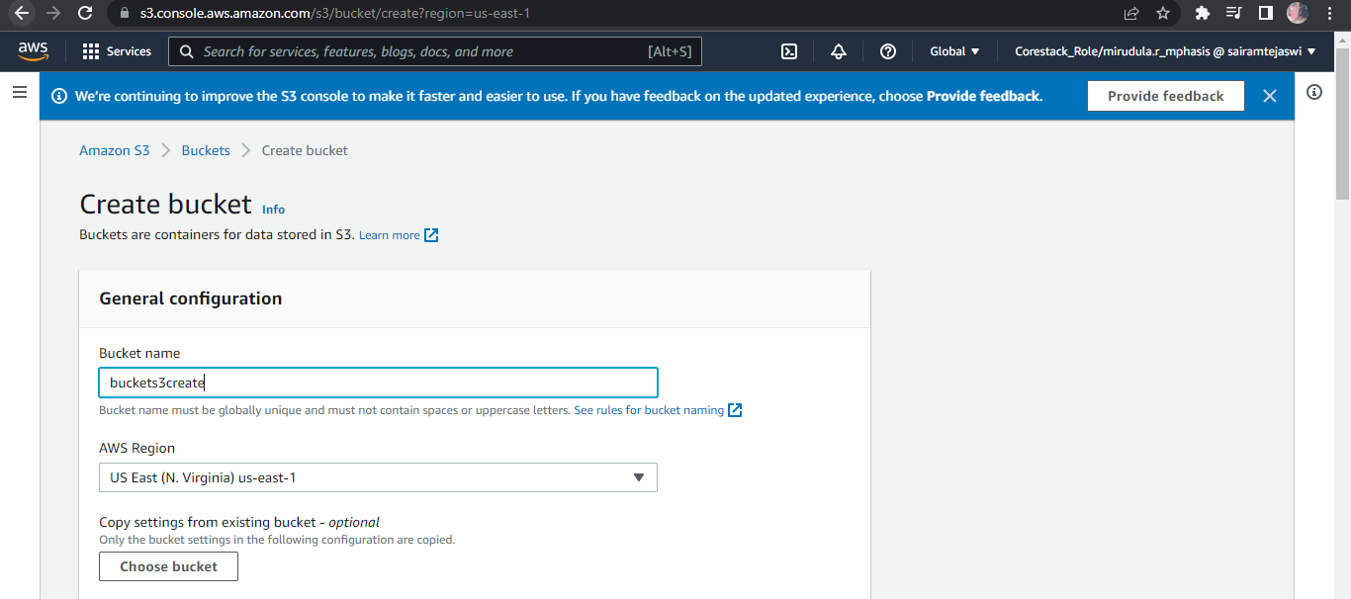

**Step 4.11.4:** Enabling ACLs

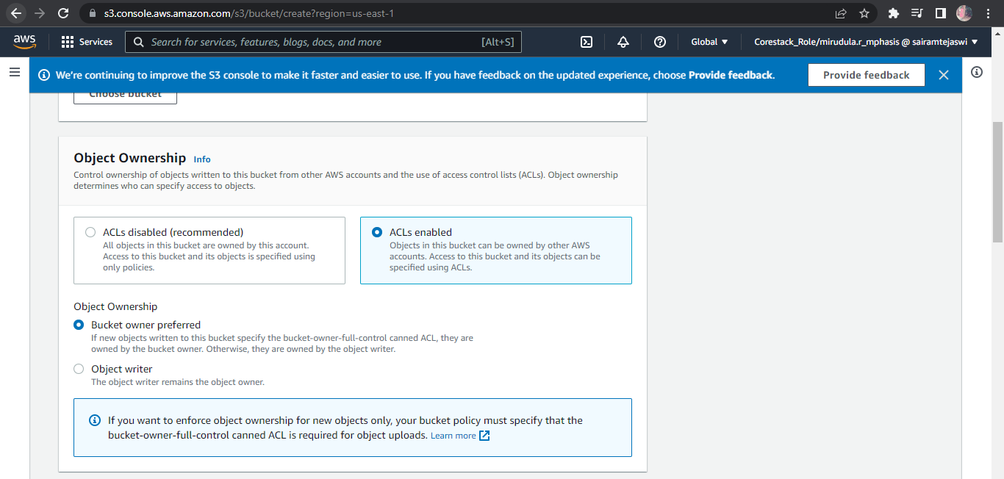

**Step 3.11.5:** Uncheck the Block all the public access

* If required, you can configure it later

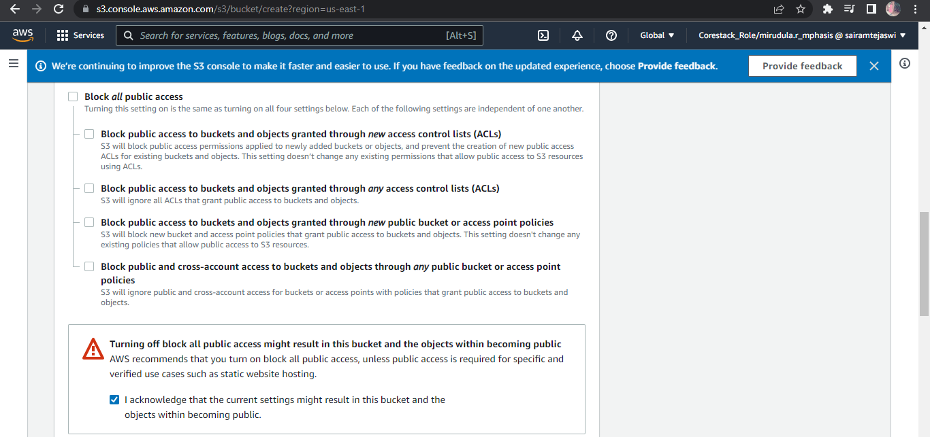

**Step 3.11.6:** Reviewing all parameters and creating the bucket

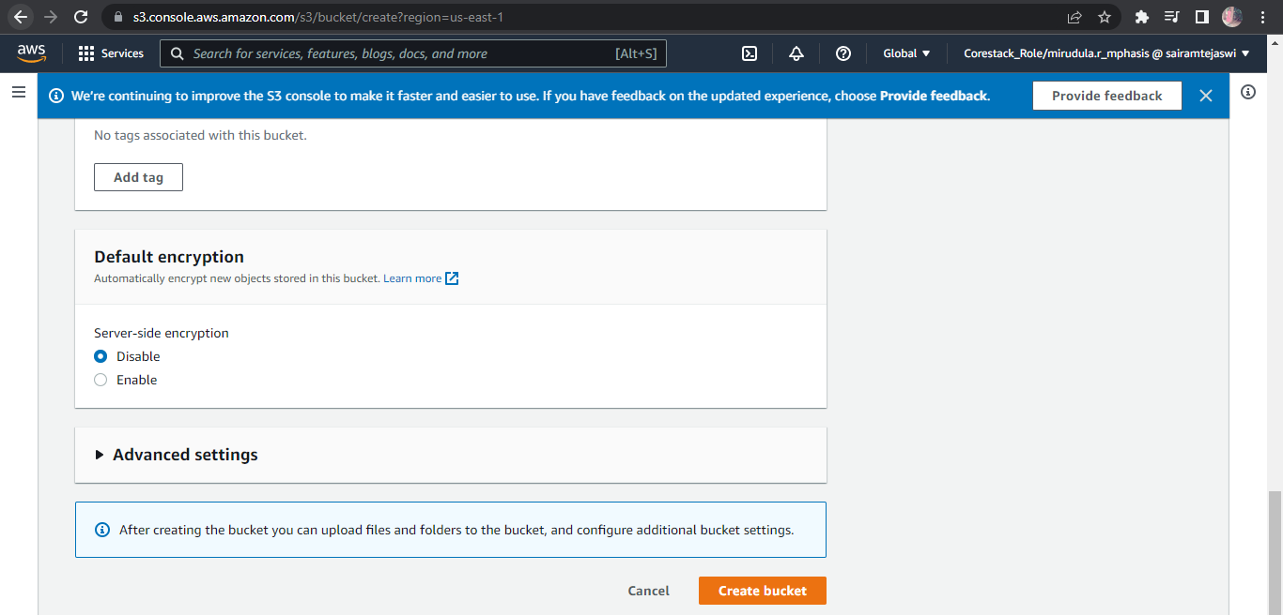

**Step 3.11.7:** Verifying the newly created bucket on the panel of S3

